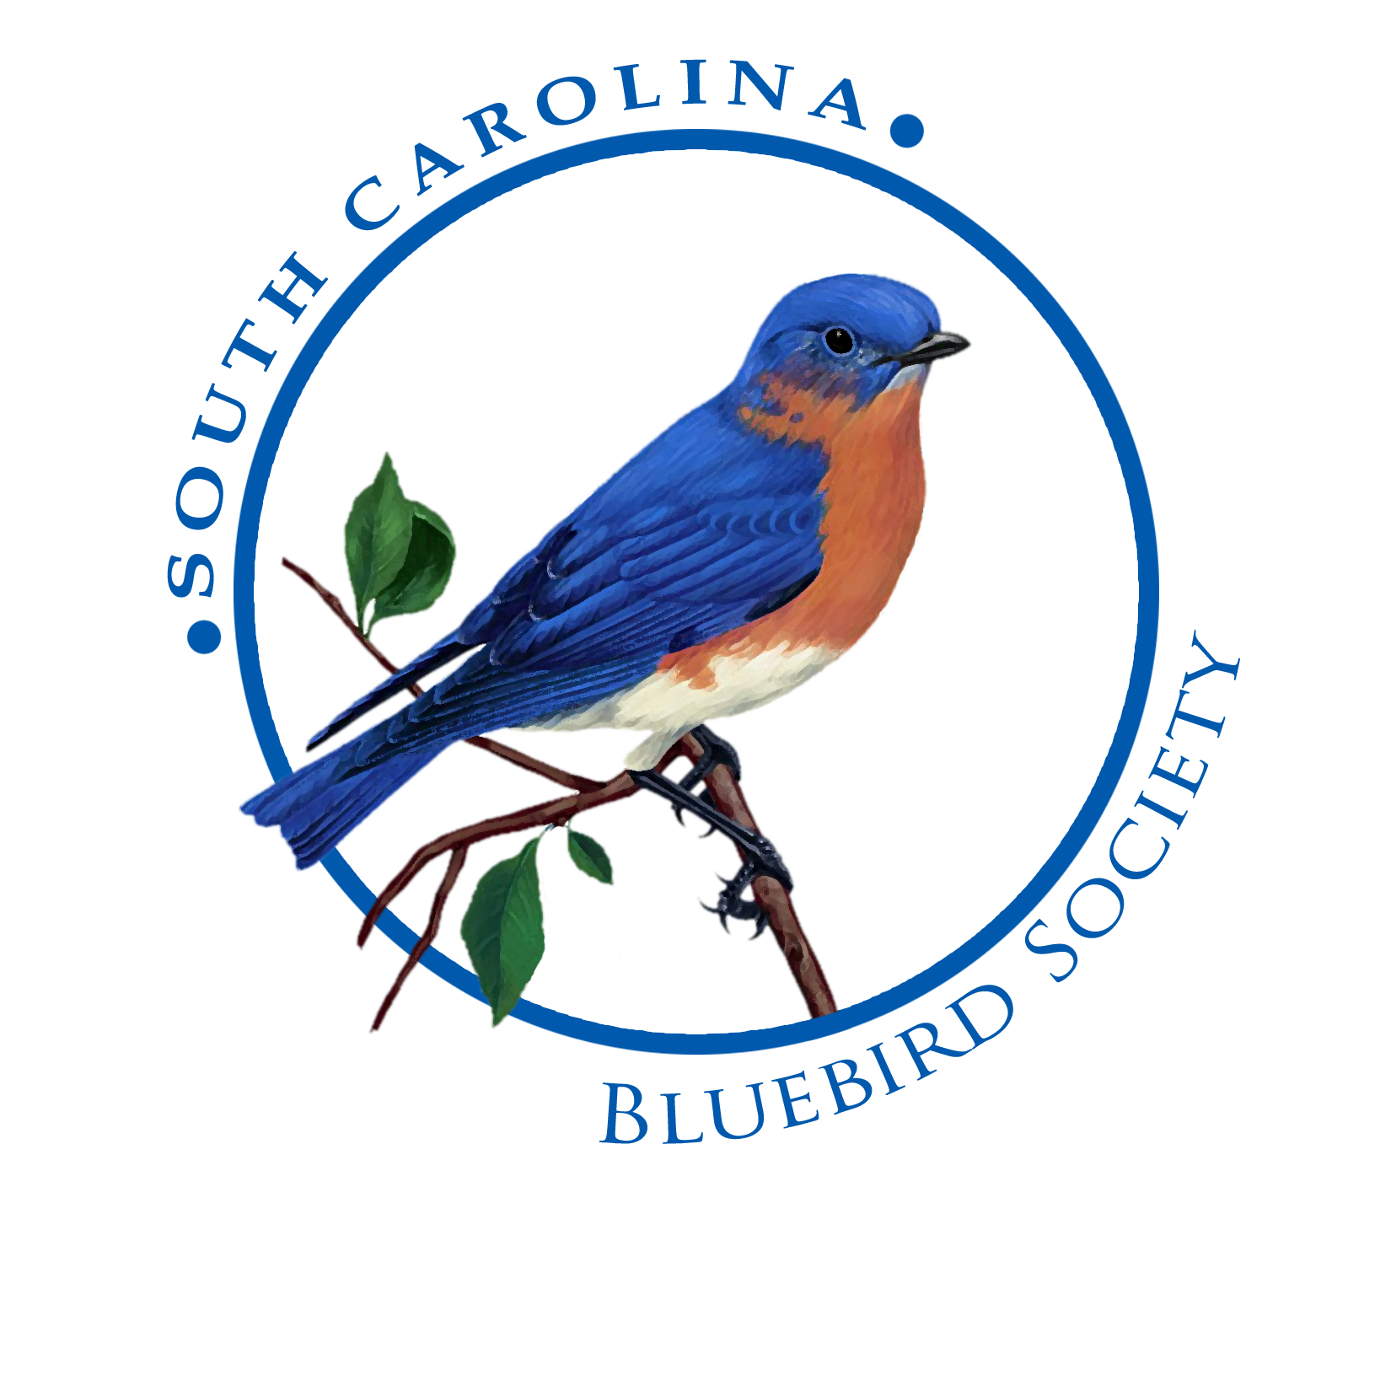
P.O. Box 5151
Aiken, SC 29804-5151 Affiliate of
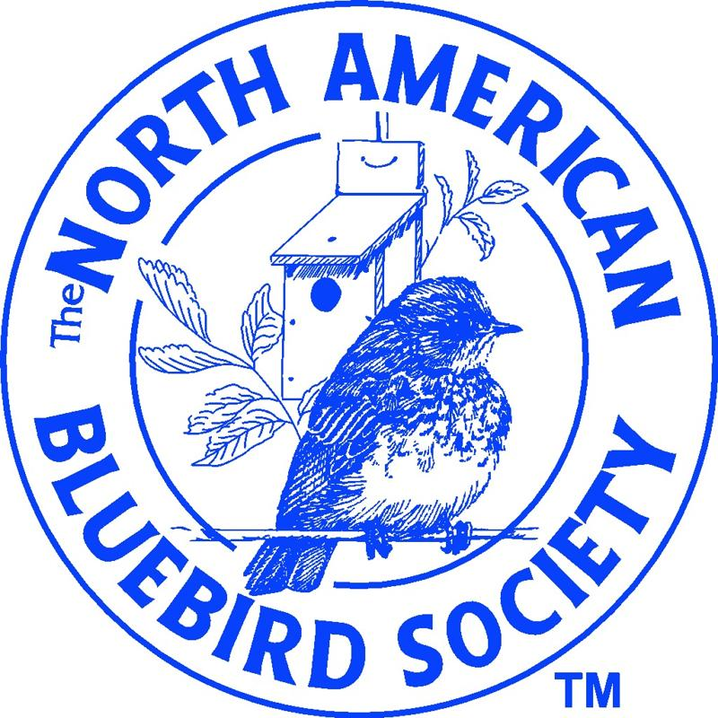
803-644-0235
www.southcarolinabluebirds.org
www.nabluebirdsociety.org

PRESENTATIONS / ACTIVITIES / EVENTS

2020

  - Jan 18 - - WBU … Surfside Beach
  - Jan 19 - - WBU … Beaufort
    - Jan 29 - - Reserve Club - BB over SC

  - Feb 05 - - Dogwood GC …Orangeburg
  - Feb 08 - - Kids Build a Box / Booth … Cold Creek
  - Feb 10 - - GIW Industries … Augusta
  - Feb 11 - - GIW Industries … Augusta
  - Feb 19 - - Aiken Garden Club
  - Feb 24 - - Cherokee GC … Barnwell
  - Feb 29 - - Wingard’s Bird Expo … Lexington

  - Mar 02 - - Summers Corner …Trail Walk & Training
  - Mar 09 - - Adult Education … Aiken High
  - Mar 10 - - Lake Keowee … Seneca
  - Mar 12 - - Augusta - Aiken Audubon
  - Mar 13 - - NWTF Installation / Repairs
  - Mar 20 - - Trinity Methodist … Aiken

  - Apr 09 - - Grovetown GC … Grovetown, GA
  - Apr 09 - - Les Dames GC … Edgefield
  - Apr 11 - - Farmers Market … Aiken
  - Apr 18 - - Earth Day … Aiken
  - Apr 21 - - Mayfield GC … Walterboro
Apr 22 - - Gay Gardeners GC … Columbia
  - Apr 25 - - Master Gardeners … Aiken

  - May 09 - - Farmers Market … Aiken
  - JUN 13 - - Farmers Market … Aiken

****** DATES TO BE SCHEDULED ******

  - Gardendale GC … Columbia

